Troubleshoot using AAD for client authentication

Service Fabric Explorer asks for certificate after AAD login
Problem: When accessing Service Fabric Explorer, after login successfully on AAD login page, it returns to home page but asks for selecting a certificate.
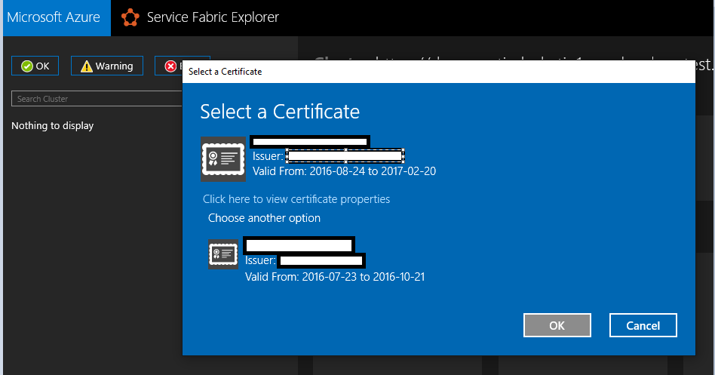

PowerShell connect fails with error: The specified credentials are invalid
Problem: When connecting to cluster using “AzureActiveDirectory” security mode, after login successfully on AAD login page, error: the specified credentials are invalid shown.
Reason: The user wasn’t assigned a role in AAD cluster application. Thus AAD authentication fails on Service Fabric cluster. Service Fabric Explorer falls back to certificate authentication.
Solution: Follow the instructions of setting up AAD and assign user roles. Also, “USER ASSIGNMENT REQUIRED TO ACCESS APP” is recommended to be turned on as the setup script does.

Sign in on Service Fabric Explorer fails: AADSTS50011
Problem: When accessing Service Fabric Explorer and trying to login on AAD sign in page, page returns sign in failure: AADSTS50011: The reply address '' does not match the reply addresses configured for the application: ''.
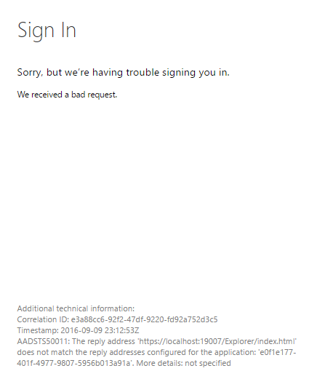
Reason: The application (Service Fabric Explorer) attempts to authenticate against AAD, as part of the request it provides the redirect return URL. But it is not listed in the AAD application ‘REPLY URL’ list.
Solution: Add URL of Service Fabric Explorer to ‘REPLY URL’ or fix it to one the items in the list. Then save.


Can I reuse the same AAD tenant for different SF clusters?
Solution: Yes. But remember to add the URL of Service Fabric Explorer to your web application otherwise the explorer won’t work.

Why do I still need server certificate while AAD enabled?
Solution: FabricClient and FabricGateway perform mutual authentication. In case of AAD authentication, AAD integration provides client identity to server and server certificate is used to verify server identity. For more information about how certificate works on Service Fabric, check X.509 certificates and Service Fabric.

